

National Textile University
Department of Computer Science
Subject: Operating System

Submitted to: Sir Nasir

Submitted by: Maha

Reg. number: 23-NTU-CS-1170
Lab 11
Semester:5th

Verify Your Setup
Before we dive in, let’s make sure Docker is working on your system.
Open your terminal and run these commands:
do
c
ker
--
version
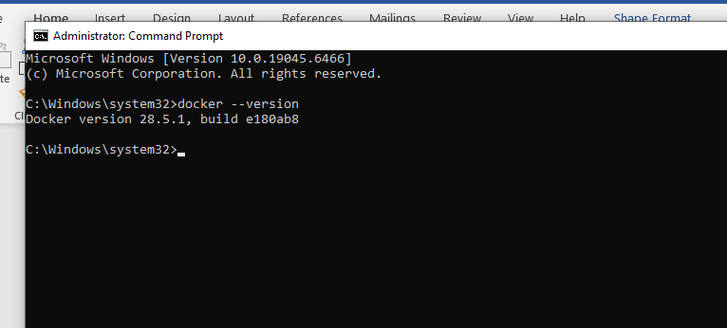

Part 4: Your First Container Exercise 1: Running Interactive Ubuntu
Let’s run an Ubuntu Linux container and explore inside it.
Type these commands in your terminal:
do
c
ker

run

-
it

u
b
untu

ba
sh
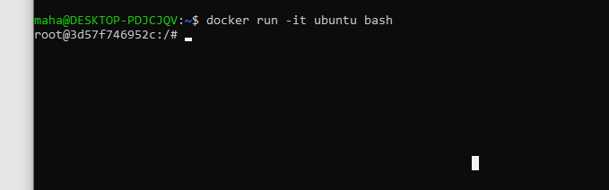
Command:
Docket version
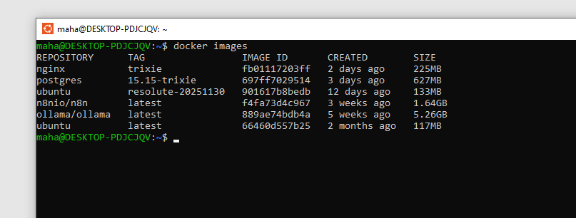
Now try these commands to explore:
Commands:

You’ll see a full Linux filesystem:
/
b
in
,
/
usr
,
/
li
b
, etc.
Shows you’re in
/
(root directory)
ls
pwd
who
a
mi
You’re the
root
user (administrator)
Shows the container’s unique ID
hostn
a
me
ca
t
/
et
c
/
os
-
rele
a
se

Exiting the Container
To leave the container:
exit
The container stops when you exit. The ubuntu image remains on your system for future use.
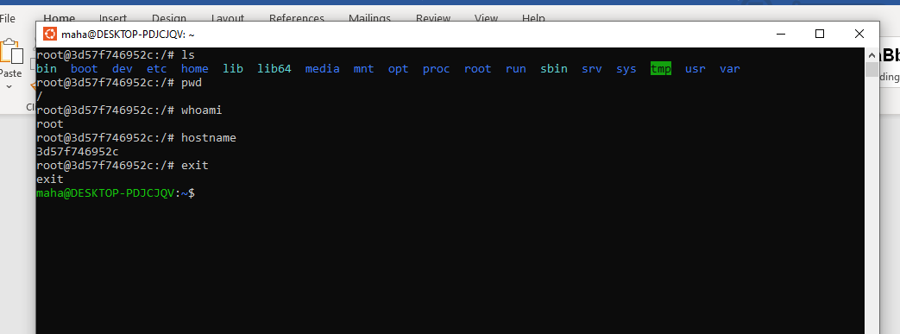

Exercise 2: Web Server in 5 Seconds
Now let’s do something even more impressive - deploy a production-ready web server instantly!

Running Nginx Web Server
Type this command:
do
c
ker

run

-
d
-
p
8080
:
80

nginx
Now open your web browser and go to: http://localhost:8080 You should see the “Welcome to nginx!” page.
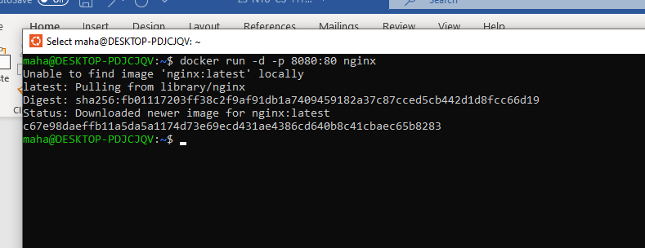
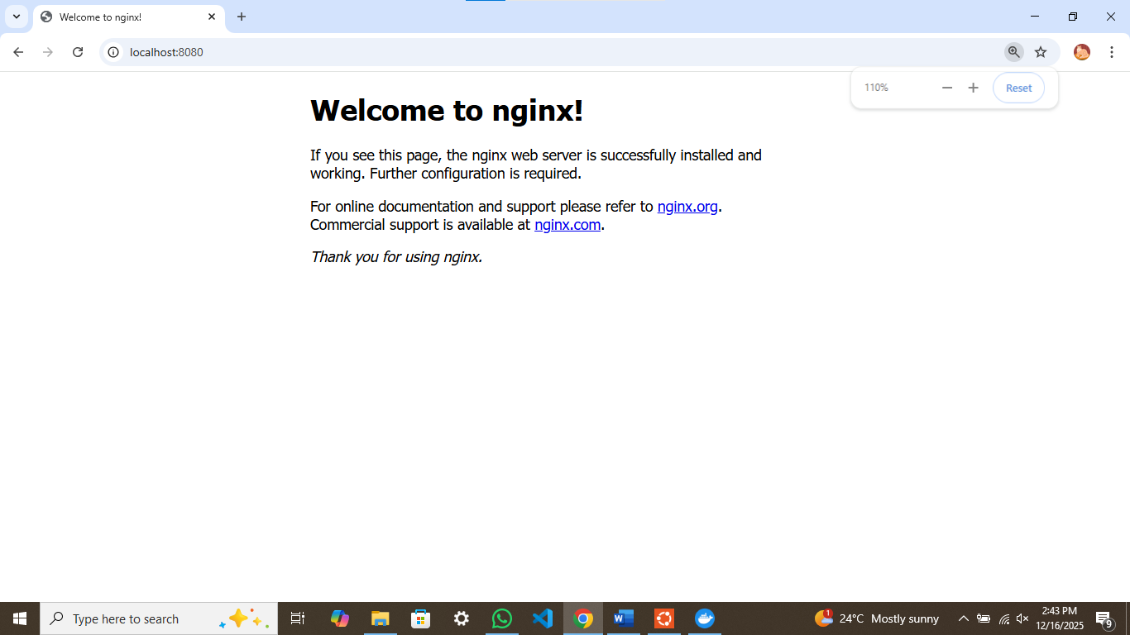

Part 5: Managing Containers
Now that you’ve created containers, let’s learn how to manage them.

Viewing Running Containers
To see what containers are currently running:
do
c
ker
ps

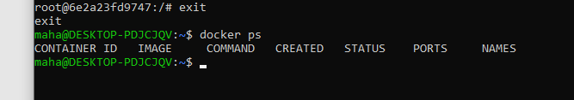

Viewing All Containers (Including Stopped)
do
c
ker
ps
-
a
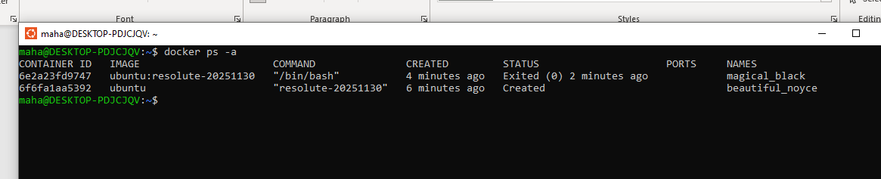
This shows both running and stopped containers. Stopped containers still exist and can be restarted!

Essential Container Commands

Removing a Container
To delete a container permanently:
do
c
ker
rm

CONTAINER
_
ID
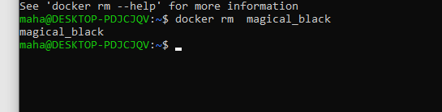

Part 6: Working with Docker Images
Let’s learn how to find, download, and manage Docker images.

Viewing Local Images
To see all images downloaded on your system:
do
c
ker

im
a
ges

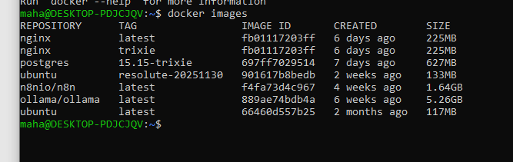

Searching for Images on Docker Hub
To find images without leaving your terminal:
do
c
ker

se
a
r
c
h

python
